The Forex MA Trading Process Based On non-linear Buffer Operators

# 1 Theoretical part

*Part1: Proof of the basic theories*

**Theorem 3.6**

Ifis strengthening buffer operator, $X=(x\left(1\right), x\left(2\right), …, x\left(n\right))$ is system behavioral data sequence, the buffer sequence is $XD=(x\left(1\right)d, x\left(2\right)d, …, x(n)d)$, are the strictly monotonic function, the monotonicity of f and g are same, and are inverse function，

$XD_{1}=(x\left(1\right)d_{1}, x\left(2\right)d_{1}, …, x(n)d_{1})$，where.

Then, is strengthening buffer operator no matter X is monotone sequence (increase/decrease) or non-monotone sequence.

**Proof**： satisfies Theorem 2 and Theorem 3

Assume  are monotone increasing function.

1. When be a monotone increasing sequence, then $x\left(k\right)≤…≤x\left(i\right)≤…≤x\left(n\right)$

Sinceis monotone increasing function, we have

$f(x\left(k\right))≤…≤f\left(x\left(i\right)\right)≤…≤f(x(n))$，

Also, because  is strengthening buffer operator, we have

$$f(x\left(k\right))d≤…≤f\left(x\left(i\right)\right)d≤…≤f(x(n))d$$

$$f\left(x\left(k\right)\right)d≤f\left(x\left(k\right)\right),where k=1,2,…n and f\left(x\left(n\right)\right)d=f(x(n))$$

Since we assumed that is monotonically increasing function, then

$$g[f\left(x\left(k\right)\right)d]≤…≤g[f\left(x\left(i\right)\right)d]≤…≤g[f\left(x\left(n\right)\right)d]$$

According to above and the theorem 1, we have：

$$g\left[f\left(x\left(k\right)\right)d\right]≤g\left[f\left(x\left(k\right)\right)\right] where k=1,2,…,n and g\left[f\left(x\left(n\right)\right)d\right]=g[f\left(x\left(n\right)\right)]$$

Which gives that $g\left[f\left(x\left(k\right)\right)d\right]≤x\left(k\right), where k=1,2,…, n and g\left[f\left(x\left(n\right)\right)d\right]=x(n)$

Therefore,  is strengthening buffer operator for monotone increasing sequence.

1. When be a monotone decreasing sequence，then $x\left(k\right)≥…≥x\left(i\right)≥…≥x\left(n\right)$，

Sinceis monotone increasing function, we have

$$f\left(x\left(k\right)\right)≥…≥f\left(x\left(i\right)\right)≥…≥f(x(n))$$

Also, because  is strengthening buffer operator, we have

$$f\left(x\left(k\right)\right)d≥…≥f\left(x\left(i\right)\right)d≥…≥f(x(n))d$$

$$f\left(x\left(k\right)\right)d≥f\left(x\left(k\right)\right),where k=1,2,…n and f\left(x\left(n\right)\right)d=f(x(n))$$

Since we assumed that is monotone increasing function，and based on Theorem 4

$$g\left[f\left(x\left(k\right)\right)d\right]≥…≥g\left[f\left(x\left(i\right)\right)d\right]≥…≥g\left[f\left(x\left(n\right)\right)d\right]$$

According to above and the theorem 1, we have：

$$g\left[f\left(x\left(k\right)\right)d\right]≥g\left[f\left(x\left(k\right)\right)\right] where k=1,2,…,n and g\left[f\left(x\left(n\right)\right)d\right]=g[f\left(x\left(n\right)\right)]$$

Which gives that $g\left[f\left(x\left(k\right)\right)d\right]≥x\left(k\right), where k=1,2,…, n and g\left[f\left(x\left(n\right)\right)d\right]=x(n)$

Therefore,  is strengthening buffer operator for monotone decreasing sequence.

1. When be a non-monotone sequence, assume that

$x\left(α\right)=max⁡\{x\left(k\right)|k=1,2,…,n\}$, $x\left(β\right)=min⁡\{x\left(k\right)|k=1,2,…,n\}$,

Proof is similar as above, is buffer operator obviously.

Because is a strictly monotonic increasing function, then $f\left(x\left(k\right)\right), k=1,2,…,n$ is non-monotonic sequence ，and $f\left(x\left(α\right)\right)= max⁡\{f(x\left(k\right))|k=1,2,…,n\}$,

$$f\left(x\left(β\right)\right)= min⁡\{f(x\left(k\right))|k=1,2,…,n\}$$

Since  is strengthening buffer operator, then we have

，

Because  is a strictly monotonic function, then

，

* ，

Therefore,  is strengthening buffer operator for non-monotone sequence.

Similarly, when are strictly monotonic decreasing functions,  is strengthening buffer operator no matter is monotonic sequence (increase/decrease) or non-monotonic sequence.

**Theorem 3.7** Letbe the weakening buffer operator, $X=(x\left(1\right),x\left(2\right),…,x(n))$ is data sequence of system original behavioral, the buffer sequence is $XD=(x\left(1\right)d,x\left(2\right)d,…,x(nd))$, are all strictly monotonic functions, the monotonicity of f and g are same, and are inverse function， $XD_{2}=(x\left(1\right)d_{2},x\left(2\right)d_{2},…,x\left(3\right)d_{2})$ where . Then, is weakening buffer operator no matter X is monotone sequence (increase/decrease) or non-monotone sequence.

Proof are similar to the process of Theorem 1.

According to Theorem 3.4 and Theorem 3.7, we can get that

Any arbitrary strictly monotonic increasing non-linear inverse functions such as

，, there should be a corresponding weakening buffer operator, and the nonlinear weakening of original sequence is realized.

Based on moving average system (build by Theorem 3.5), we can construct a new non-linear moving average system by using weakening buffer operator. The Guangfeng Xu has proved that non-linear system can be used in Chinese stock market by forecasted the nonlinear analysis of stock market.

*Part2: Buy and sell points selection*

The moving average system usually has the following two decisions about the purchase order：

1. Based on single moving average.

Observing the breakthrough situation of stock closing price for its moving average. It is generally believed that the closing price of the moving average is 1%. However, in the real market, there are many false breakthroughs, especially in China's stock market. It will not have effective breakthrough even the stock close price exceed the moving average 1%, because the value 1% is just a reference.

1. Based on multiple moving averages.

Assuming that price (p) and time (t) have function relation: ，At the moment (the current moment), is known when,  is unknown when. The primary goal of market participants is to find buying and selling moments. become maximum value since >. It means that is largest and  is smallest. According to the analysis of 4.3, we will know that there is no autocorrelation in stock prices. So Investors can't determine the development trend of the post price from the previously known moments. However, the moving average will expresses this trend. We can determine trade point by using Granville's Law to determine gold intersection and death intersection:



The stock image constitutes the golden intersection at the  moment (buying point), when t equal to . The stock image constitutes the death intersection at the  moment when （，）. The empirical analysis in this study all based on this above theory. Under lots of marketing experience and research, the combination of moving average systems which using frequently is: 5 days + 10 days, 10 days + 30 days, 30 days + 60 days and 5 days +60 days. All these four moving average systems not only can good fitting the market trends, but also can provide reference index for investors who have different operating styles. The combination 5 days + 10 days is fast moving average. It can be very sensitive to provide the changes of stock price because the benefits and the trend of stock price from this combination have high correlation. According to the analysis of literature [27], compare to the long-term average moving, the short-term average moving have higher probability to gain excess profits. However, in analysis above, traditional moving average has obvious hysteresis due to its internal characteristics. Moreover, the market tends to reverse after the system sends this buy and sell signal. This reverse will makes many traders lose judgment on the current market. Therefore, in the following empirical analysis, we select MA5+MA10 combination and use the discriminating formula of the non-linear trading point as follows:

 （5.1）

In the above formula, it will produce a buy signal when  > 0; it will produce a sell signal when  < 0.  means the average moving price of stocks, n means average period.  means the fast and slow moving averages. is the extend which comes from the fast moving average break through the slow moving average. The above formula shows that it will produce the corresponding operate signal after the proper extend from fast moving average breaks above or below the slow moving average. It can decrease the probability to make operating errors. In this study, we set  to be 1% because the moving average rule (its breaking extend is 1%) will have higher profitability.

In order to reduce the impact of its hysteresis, we will discuss the moving average system which constructed by the New Non-Linear Grey Buffer Operator whether can be optimized in the marketing application. In the following analysis, we will not think about the subjective factors when we research the trading signals of MA lines. It means we assume that investors will make decision according to the moving average system not personal preference.

# 2 Practical Parts:

For this part, we choose 6 different currency pairs to serve as our system testing objectives, we chose the data period from 01/01/2013 to 12/29/2017. We did following steps to get the final outputs:

In accordance with the basic fact that newer values will influence more on the data behaviors, we give the different weights to each value, ascending from 1 to $^2$.

First, we apply R to visualize the 3 non-linear system, by visualization, we can observe the differences among the new systems.

Second, it is because the forex market has two sides of trading (sell and buy sides), all of them are considered to trade in either sell or buy side. We assume that the customers have the ability to recognize the market trends and in all of the increasing or decreasing portfolios, they sell out or buy in respectively. We conduct the practical experiments based on the previous theoretical parts.

Third, we apply the non-linear moving average systems in two different monotonically function pairs: $f\left(x\right)=x^{3}$, $g\left(x\right)=\sqrt[3]{x}$ and $f\left(x\right)=\log_{3}x$, $g\left(x\right)=3^{x}$, (3 is a most used number in financial markets , , however, any other numbers can be chosen, not confined on 3. We apply them to the moving average system and then compare the outputs with SMA strategy.

(1) AUD vs USD:

Before we start to run our strategy on the data, we need first to test the normality and AR process.

Step 1: Test the normality of the return and the Auto-Regressive:

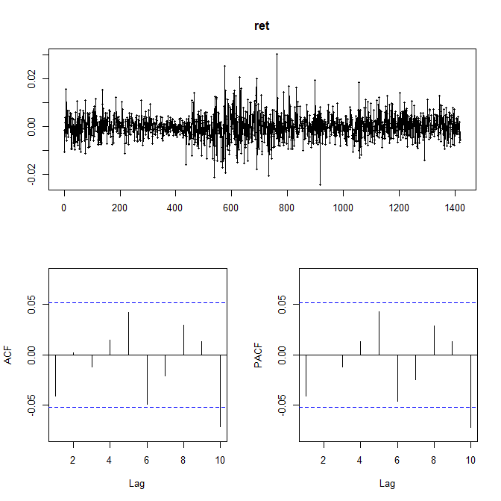

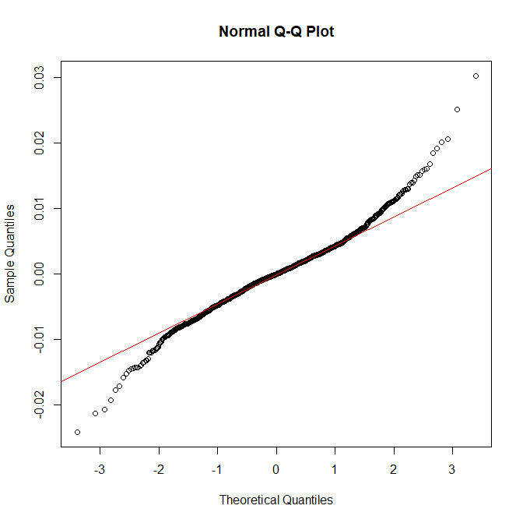

Figure 1

As we can see in the test output, the return data is almost subject to normal distribution and there is no Autoregressive relationships before lag10. Therefore, our method is effective.

Step 2: Data Pre-processing and visualization:

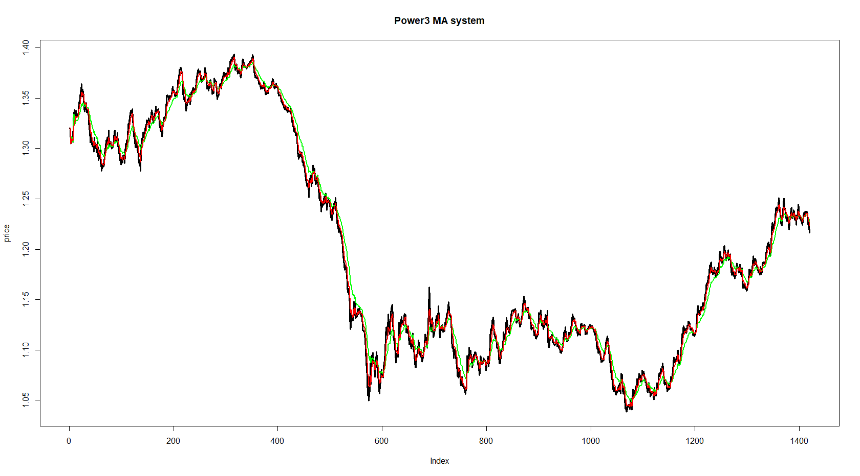

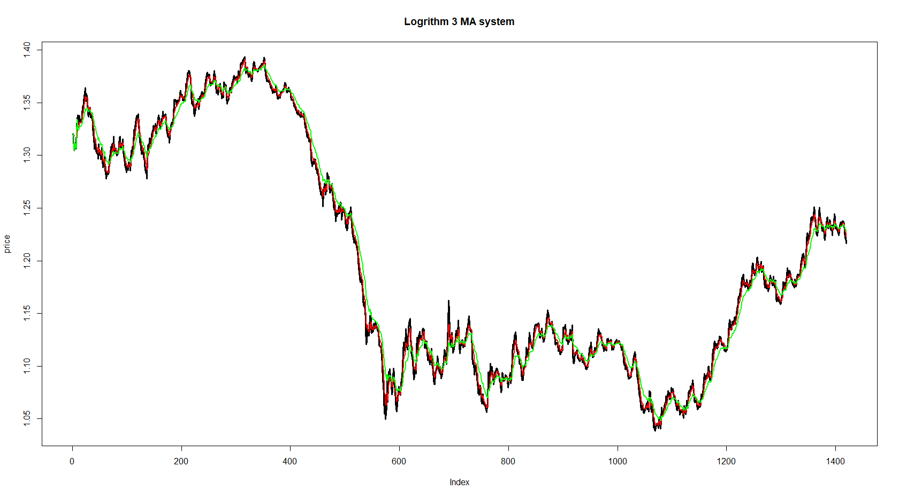



Figure 2

(In figure 2, among the three different lines, the red line stands for the MA5, while the green line represents the MA10, black line is the stock price)

By visualizing the data, we can see that the 3 moving average system nearly gives the same trend with the price changing. However, if we look thoroughly, we can find that the non-linear weighted system will be more sensitive to the price.

Step 2: Setting the trading rules:

In order to select the appropriate trade rules, we summarize the return data and set the ε – value as 0.001 based on the data we got



Step 3: Compute the 3 different systems cumulative return

In order to decide which one has the best outcome, we code the trading part and calculate the cumulative returns based on the corresponding MA system in the holding portfolios, we have the following figure:

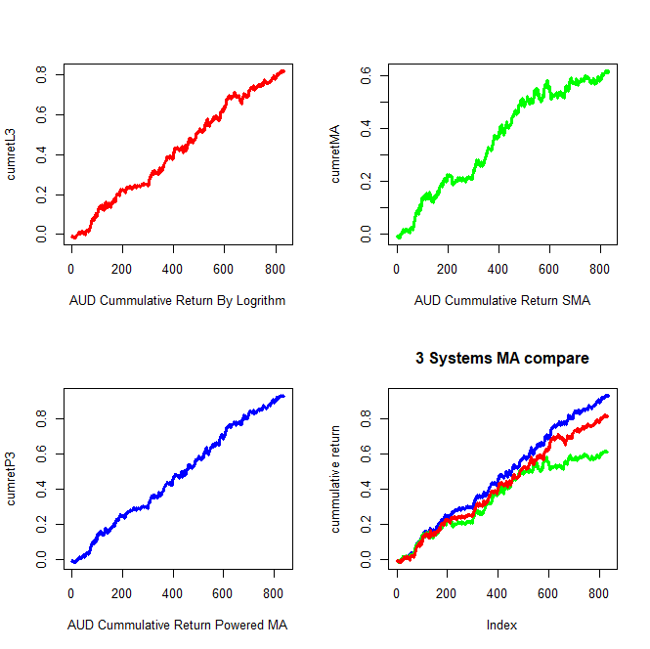

Figure 3

As we can see in figure 3, the blue line stands for the cumulative return of 3-powered Moving Average Systems, red line stands for the cumulative returns of logarithm 3-based Moving Average Systems, the green line, which is the cumulative returns of the Simple Moving Average Systems. Obviously, the simple moving average system gives the least cumulative returns, the Powered and Logarithm MA system all give more cumulative returns.

Furthermore, we compute the moving average cumulative ratios of these three methods, we have the outcome:

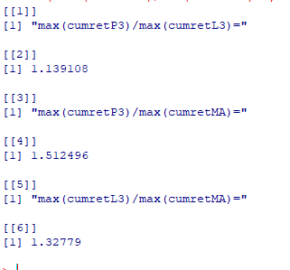

Figure 4

As we can see in the output values, the highest ratio is given by the Powered 3 MA system and then is the 3 based Logarithm system, the Powered 3 MA system and 3 based Logarithm system are very close which the ratio between them is only 1.14.

(2) EUR vs USD

We repeat the same procedures above on EUR/USD, and we have the following output:

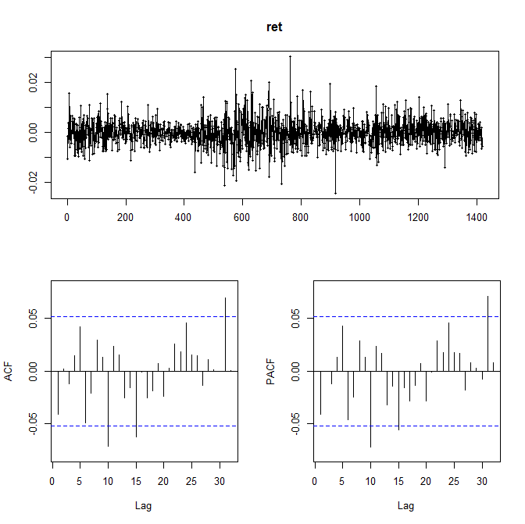



Figure 5

The normality testing and the AR process indicate that the return of EUR vs USD is effective and which can be applied to the practical part.

It is because the space limitation, we will give the final output and skip the visualization of the stocks and MA systems.

Final output of EUR vs USD:

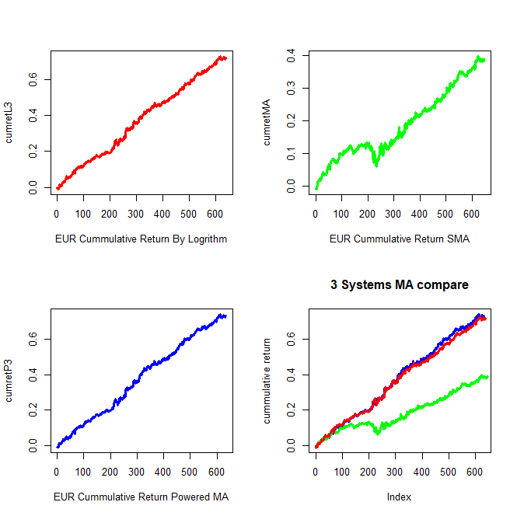

Figure 6

As we can see in the final outcome, the non-linear MA system gives better cumulative return on the trading period, also, the SMA gives an obvious negative return at some time points, which will lead to a bad influence of the trading procedure. However, the non-linear MA system, both powered and logarithm system give more stable trading process, the cumulative returns, though just around 0.6, it is much better than the Simple Moving Average strategy.

We compute the ratio among the three cumulative returns as well, the output is shown as follow chart:

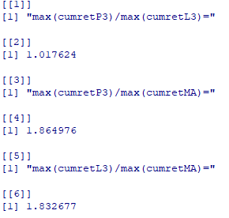

Figure 7

From Figure 7, we can see that the cumulative return of 3 powered based moving average and 3 based logarithm returns are 1.86 and 1.83 time to the SMA cumulative return respectively, which explain the superior attributions of non-linear system.

(3) GBP vs USD:

The normality and the AR process are tested, the results show that the return is significantly subject to normal distribution and no auto regressive before lag10.

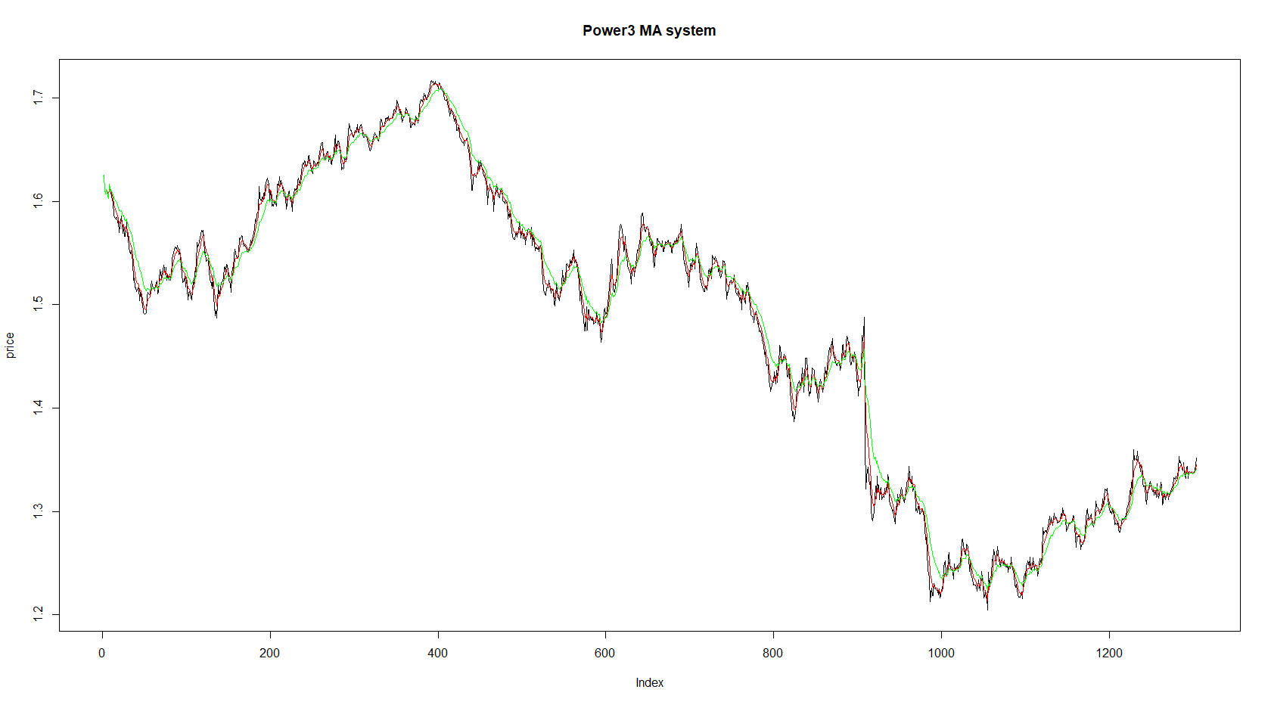

The stock price, keep decreasing in during the time period, so we do sell trades, we have the result shown as follows:

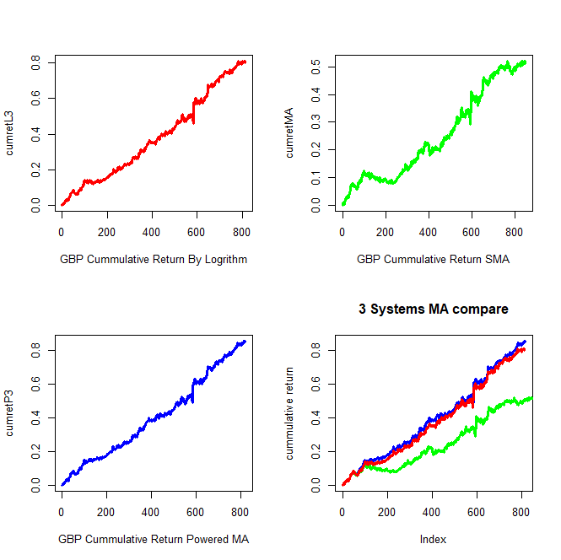

Figure 8

(Blue, Red, Green stand for Power MA system Returns, Logarithm MA system Returns, SMA Returns respectively)

The figure8 shows the cumulative returns of the 3 different MA systems, clearly, the logarithm and the Power systems give higher cumulative returns than the SMA.

Once again, we compute the ratios among them:

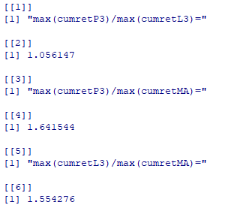

From this result, we can see that the cumulative return based on either logarithm or power system can raise the cumulative return substantially.

(4) USD vs JPY

Asia market is tasking an increasingly important position in the world, we adapt the data of USD vs JPY to test if the strategy is also work on Asia market. From 2013 to 2017, the overall trend of the currency is growing steady, so we assume that the traders will be in the buy side, we apply the strategy mentioned above and we get our results as following:

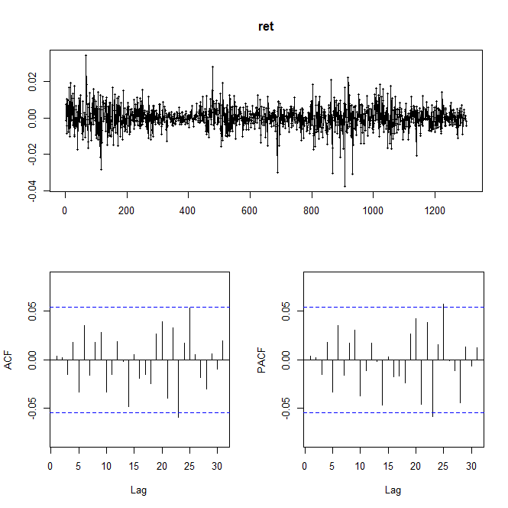

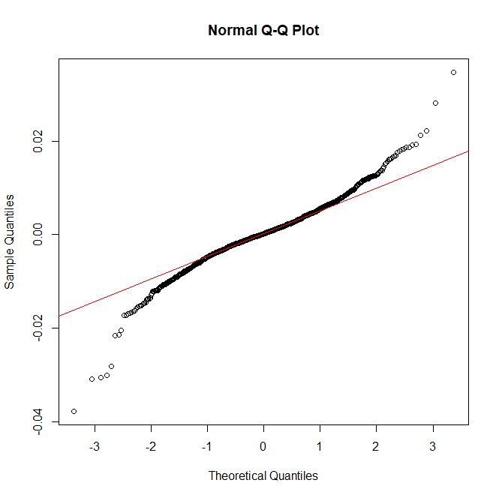

Figure 9

In figure 9, we find that the return of USD vs JPY is effective and significant to apply the strategy on it.

We apply the mentioned 3 MA systems on the data, and give the output:

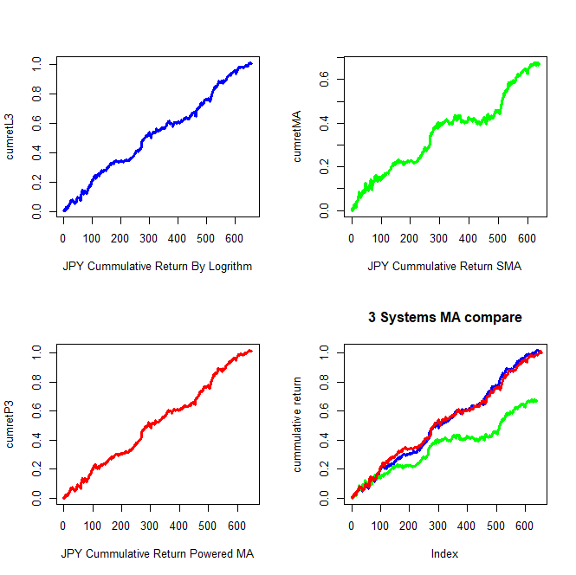

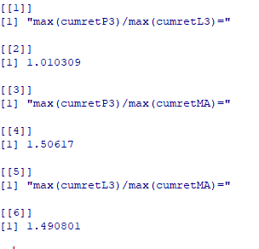



Figure 10

In Figure 10, the blue, red and green curve represents for the Logarithm, Powered and MA system respectively, obviously, the non-linear Moving average systems give much higher cumulative returns than what we got in the SMA system. Also, the trading times based on Log3 and x^3 have less trading times than the SMA, which means that the non-linear MA system is more effective, traders may benefit more in less trading times.

(5) USD vs INR

India is a developing country in Asia, as the biggest country of software and engineering science, Indian currency is an important element of Asia financial market, the currency of India is Rupee which is gaining a growing number traders from all over the world. We run our test on USD vs INR to see if our strategy is also useful on developing country.

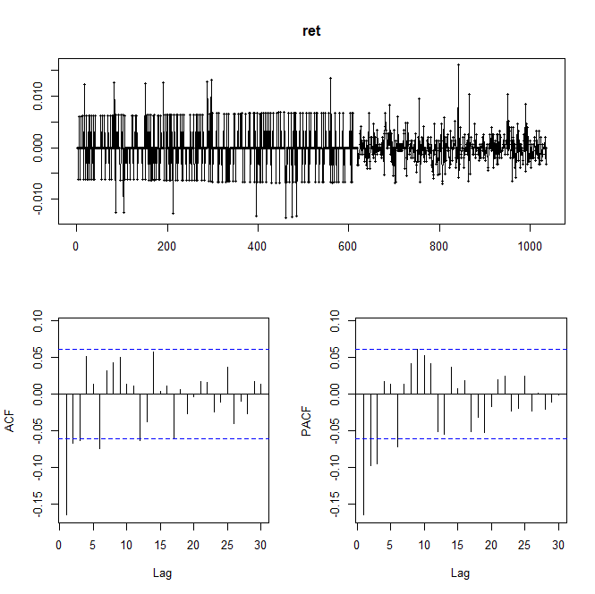

Figure 11

As we can observe in the output plots, the return of Indian Rupee an ARMA(1,3) series, we build an model on the data to see what we can get.

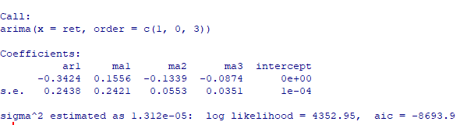

We have a model shows that there exists a AR and MA process, we still apply the strategy on the data and get the final result:

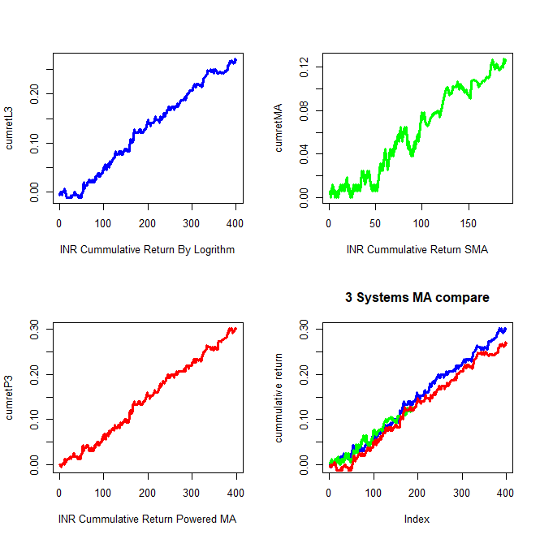

Figure 12

From Figure 12, we see that the trading portfolios of SMA is much less than the portfolios of the non-linear MA systems, furthermore, we compute the trading times to see what hide behind this abnormal output:

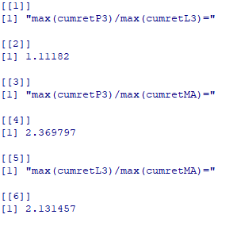



Figure 13

From Figure 13, we see that the log3 and x^3 MA system give same trading times which is 29, while SMA system gives more trading times which is 59, this means that the SMA system leads to a more times of trades but give less cumulative return, while the other 2 non-linear systems give less trading times but have more cumulative return. The cumulative returns of the 2 non-linear systems are 2.37 and 2.13 times to the SMA cumulative returns respectively. We also compute the total holding days based on the 3 different systems:



Figure 14

As our analysis before, we can see that we hold Rupee more days on the two non-linear systems, while we hold less days under the SMA system, this output also indicate that non-linear MA systems will give more profits on Rupee, if we invest it in a long perspective.

(6) USD vs CHF

Swiss CHF had a black swan before, so it is always considered to be a representative of the unstable currencies, we want to show that if our new systems can be also used in the generalized areas, CHF is suitable currency to test.

Followed by the previous processes, we have the outcome:

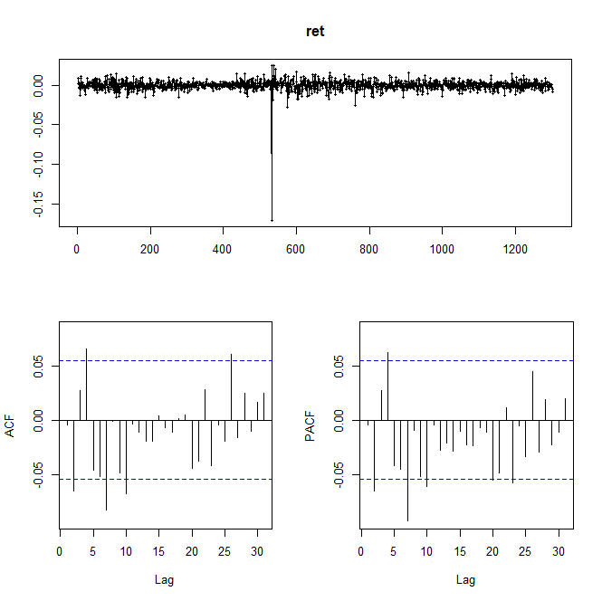

Figure 15

Obviously, the “black swan” makes the currency has a certain “outlier”, in order to figure out where is the outlier, we plot the stock price:

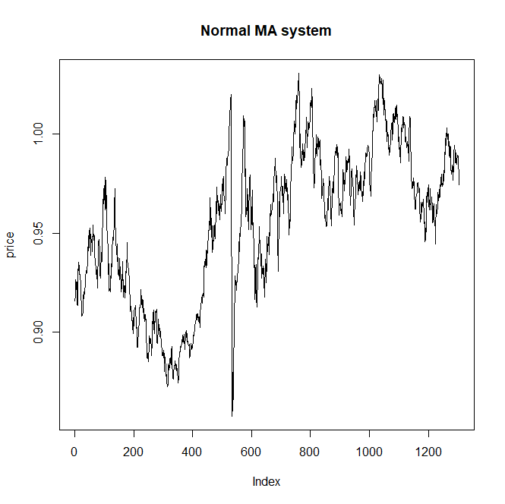

Figure 16

In Figure 16, clearly, we can observe that the “black swan” point, also, we can see the CHF currency is fluctuating during the 5 years period; it is also a good way to see if our system can be used in the fluctuation market. Instead of deleting this point, we continue our process on CHF and have the following output:

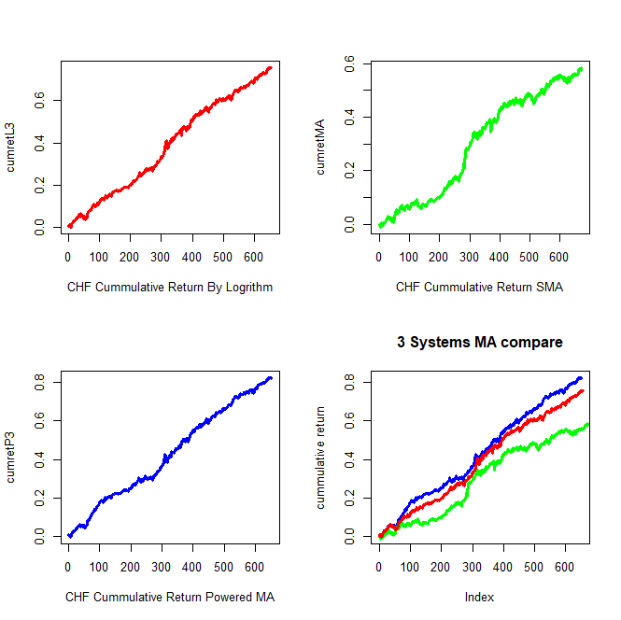

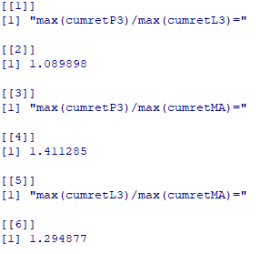

Figure 17

Once again, we can see that the 2 non-linear system have higher cumulative returns compared to the traditional SMA method, what’s more, we calculate the trading times and total holding days:





Figure 18

As we can see in the above output, the trading times of both log3 and x^3 systems are less than the times of SMA, but the non-linear systems give more cumulative return, which means that the non-linear MA system is helpful and more effective. The non-linear MA systems can be applied in the fluctuation currency markets not only confined to either increasing or decreasing markets.

# Conclusion

As we have done above, we first prove the basic theories of this paper, then we create 2 different non-linear moving average systems: log3 and x^3 systems, based on the theoretical parts. After that, we decide the buying/selling points of the trading strategy. Finally, we apply the systems into the 6 different major currencies, all of the outputs strongly indicate that the non-linear MA systems, compared with the SMA method, have its own superior properties, these outputs provide a concrete proof of the advantages of the original thoughts.